-

DBMS Mini Project Report
On
Credential Stuffing And Account
Takeover Detection System

Submitted by
Group 4

Project Members

Suhani Shah(1262242212)
Shreya Pandey (1262242081)
Sneha Kunnummal(1262242233)
Anil Neerati (1262243623)

Under the Guidance of

Dr. Sukhada Bhingarkar

Department of Computer Engineering and Technology
MIT World Peace University, Kothrud,
Pune 411 038, Maharashtra - India
2024-2025


DEPARTMENT OF COMPUTER ENGINEERING AND TECHNOLOGY

C E R T I F I C A T E

This is to certify that Suhani Shah, Shreya Pandey, Sneha Kunnumal and Anil Neerati of SYBTech.(CSF ) have completed their project titled Credential Stuffing And Account Takeover Detection System and have submitted Mini Project Report under the course Database Management System Laboratory (CSF20080) for the academic year 2025-2026

Dr. Sukhada Bhingarkar
Subject Faculty
Department of CET
MIT World Peace University, Pune

Date: ___________

Acknowledgement

We express our sincere gratitude to Dr. Sukhada Bhingarkar for guiding us throughout the DBMS mini project. Her valuable suggestions, constant encouragement, and insightful feedback played a crucial role in shaping this work and helped us complete the project successfully.

We are also thankful to the Department of Computer Engineering and Technology, MIT-WPU, for providing us with the necessary resources, infrastructure, and academic environment required for the successful completion of this project.

Finally, we would like to thank our classmates and peers for their constructive discussions, suggestions, and moral support, which greatly contributed to the successful completion of this project.

Name of the Students
Suhani Shah
Shreya Pandey
Sneha Kunnummal
Anil Neerati
Abstract

This project presents an Adaptive Cybersecurity Intelligence System designed to monitor multi-domain login activities and prevent unauthorized access. Unlike static authentication systems, this platform integrates Real-time IP Geolocation and Behavioral Risk Scoring to analyze user behavior across Social, Banking, E-commerce, and Educational portals. The system utilizes a structured relational database to correlate login attempts with geographic data and historical reputation scores. By implementing forensic analysis logic, the system identifies anomalies such as "Frozen Account" access attempts and foreign IP intrusions, providing an Admin Dashboard with automated AI-driven security suggestions.

List of Figures

Sr No. | Title | Page No.
1 | ER Diagram | 10
2 | Police Login Terminal Interface | 19
3 | Infrastructure Load Analysis dashboard | 19
4 | System Monitoring And Alert Overview | 19
5 | System Monitoring And Alert Overview | 19
6 | Master Forensic Audit Trail | 19
7 | Forensic Threat Intelligence Panel | 19
8 | Network Node Investigation Interface | 19
9 | Active Connections And Reputation Score Monitor | 20
10 | High-Risk Activity Trail Log | 20
11 | User Login Page — Portal Selection and Sign in Interface | 20
12 | Create Account Page — New User Registration Form | 20
Contents

Chapter | Title | Page No.
Chapter 1 | Abstract | 4
Chapter 2 | List of Figures | 5
Chapter 3 | Introduction (Motivation and objectives) | 6
Chapter 4 | Problem Definition | 8
Chapter 5 | Tools and Technologies Used | 9
Chapter 6.1 | Database Design | 10
Chapter 6.2 | Normalization Details | 11
Chapter 8.1 | Database Schema | 12
Chapter 8.2 | DDL | 13
8.3 | DML | 14
8.4 | Triggers | 15
8.5 | PL/SQL Procedure/Function | 16
9 | Frontend GUI Screenshots | 19
10 | Conclusion | 21
11 | References | 22

Introduction

In the modern digital era, cybersecurity has become one of the most critical concerns for individuals, organizations, and governments. With the rapid growth of internet-based services and online platforms, the risk of cyber threats such as unauthorized access, data breaches, and identity theft has significantly increased. Traditional authentication mechanisms, which rely solely on usernames and passwords, are no longer sufficient to ensure system security. Attackers are now using advanced techniques like brute force attacks, phishing, and credential stuffing to compromise user accounts.
This project presents a database-driven cybersecurity system that enhances login security through intelligent behavioral analysis. Instead of relying only on static credentials, the system monitors user login patterns such as IP address, login time, and activity behavior. By analyzing these patterns, the system can identify suspicious activities and potential intrusions in real time. The system also maintains detailed logs of user actions, enabling administrators to monitor, analyze, and respond to threats effectively.

The project integrates database management concepts with backend programming to create a robust and scalable solution. It demonstrates how structured data storage, normalization, and SQL operations can be combined with application logic to build a secure authentication and monitoring system.
Motivation
- Increasing number of cyberattacks and security breaches
- Limitations of traditional password-based authentication systems
- Need for intelligent and adaptive login verification methods
- Importance of real-time monitoring and threat detection
Objectives
- To design and implement a secure and normalized database for storing user and login data
- To detect suspicious login attempts using behavioral analysis techniques
- To develop an admin monitoring system for tracking user activities
- To implement SQL operations including DDL, DML, DCL, and triggers
- To ensure data integrity, security, and efficiency using database normalization

Problem Definition

The objective of this project is to develop a database-driven system capable of detecting and preventing unauthorized login attempts by analyzing user behavior and maintaining detailed activity logs. The system should identify anomalies such as unusual login locations or repeated failed attempts and generate alerts for administrative action.

Tools and Technologies Used

The successful implementation of this project requires the integration of multiple technologies across different layers of the system. Each tool plays a crucial role in ensuring the functionality, performance, and security of the application.

Database
- MySQL : Used as the primary relational database management system to store user information, login records, IP addresses, and activity logs. It ensures data consistency, integrity, and efficient querying.

Backend
- Python (Flask Framework) : Flask is a lightweight web framework used to handle server-side logic, routing, and database interactions. It enables the implementation of authentication logic and behavior analysis.

Frontend
- HTML (HyperText Markup Language) – for structuring web pages
- CSS (Cascading Style Sheets) – for styling and layout design

Libraries Used
- mysql.connector – for connecting Python with MySQL database
- datetime – for handling timestamps and login time analysis
- random – for simulating test data such as login attempts
- requests: Integrated to communicate with external apis for real-time geographic tracking of users worldwide.
- pandas: Utilized for data manipulation and generating security audit reports.
Platform
- The system is designed to run on both Linux and Windows, ensuring flexibility and portability.

Database Design

A well-structured database design is essential for maintaining data integrity and ensuring efficient operations. This project follows proper database design principles, including Entity-Relationship (ER) modeling and normalization.

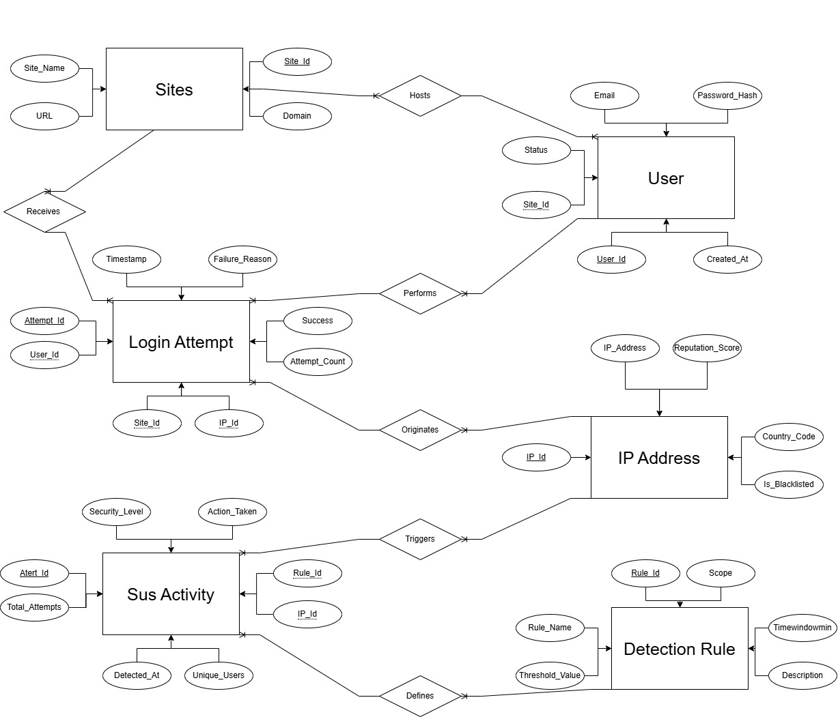

Fig 1: ER Diagram

Normalization

1. First Normal Form (1NF)
A table is in 1NF if it contains only atomic values and there are no repeating groups.
- Application: Initially, a single table might have stored a user and all their login IPs in one field. In this project, we ensured every attribute (like EMail or IPAddress) contains a single value.
- Result: Every row in the user, loginattempt, and ipaddress tables is unique and identified by a Primary Key (UserId, AttemptId, IPId).

2. Second Normal Form (2NF)
A table is in 2NF if it is in 1NF and all non-key attributes are fully functionally dependent on the primary key.
- Application: We separated IP details from Login records. If we kept the CountryCode and RepScore inside the loginattempt table, that data would be redundant every time the same IP logged in.
- Result: Created a separate ipaddress table. Now, the CountryCode depends only on the IPId, not on the AttemptId. This prevents "Update Anomalies"—if an IP's reputation score changes, we only update it in one place.

3. Third Normal Form (3NF)
A table is in 3NF if it is in 2NF and there are no transitive dependencies (non-key attributes should not depend on other non-key attributes).
- Application: We separated Site Details from the User and Login tables.
  - Previously: A login record might have stored SiteName and SiteURL.
  - Problem: SiteURL depends on SiteName, which depends on the AttemptId. This is a transitive dependency.
- Result: Created the site table. Now, the loginattempt table only stores a SiteId (Foreign Key). The names and URLs are stored independently, ensuring that if "EduPortal" changes its URL, we don't have to update thousands of login records.
Database Schema
- User Table: UserId, EMail, PasswordHash, SiteId, Status (Active/Frozen).
- Site Table: SiteId, SiteName, Domain, URL.
- IPAddress Table: IPId, IPAddress, CountryCode, RepScore, IsBlacklisted.
- LoginAttempt Table: AttemptId, UserId, IPId, SiteId, Success, CreatedAt, LogoutAt.
- SusAct (Suspicious Activity) Table: LogId, UserId, IPId, Reason, DetectedAt.

DDL (Data Definition Language)

mysql> create database MINIPROJECT;
Query OK, 1 row affected (0.01 sec)

mysql> use miniproject;
Database changed
mysql> create table Site(
-> SiteId int auto_increment primary key,
-> SiteName varchar(100),
-> Domain varchar(100),
-> URL varchar(255));
Query OK, 0 rows affected (0.06 sec)

mysql> create table User(
-> UserId int auto_increment primary key,
-> EMail varchar(255),
-> PasswordHash varchar(255),
-> SiteId int,
-> Status varchar(20),
-> CreatedAt datetime,
-> foreign key(SiteId) references site(SiteId));
Query OK, 0 rows affected (0.05 sec)

mysql> create table IPAddress(
-> IPId int auto_increment primary key,
-> IPAddress varchar(45),
-> IsBlacklisted boolean,
-> CountryCode char(2),
-> RepScore int);
Query OK, 0 rows affected (0.06 sec)

mysql> create table DetectionRule(
-> RuleId int auto_increment primary key,
-> RuleName varchar(100),
-> ThresholdValue int,
-> TimeWindowMin int,
-> Description text,
-> Scope varchar(20));
Query OK, 0 rows affected (0.06 sec)

mysql> create table LoginAttempt(
-> AttemptId int auto_increment primary key,
-> TimeStamp datetime,
-> Success boolean,
-> FailureReason varchar(100),
-> UserId int,
-> SiteId int,
-> IPId int,
-> AttemptCount int,
-> foreign key(userid) references user(userid),
-> foreign key(siteid) references site(siteid)
-> foreign key(ipid) references ipaddress(ipid));
Query OK, 0 rows affected (0.15 sec)

mysql> create table SusAct(
-> AlertId int auto_increment primary key,
-> DetectedAt datetime,
-> RuleId int,
-> IPId int,
-> UniqueUsers int,
-> SecurityLevel varchar(20),
-> ActionTaken varchar(50),
-> TotalAttempts int,
-> foreign key(ipid) references ipaddress(ipid),
-> foreign key(ruleid) references detectionrule(ruleid));
Query OK, 0 rows affected (0.05 sec)

DML (Data Manipulation Language)

mysql> insert into detectionrule values
-> (1, 'Brute Force Detection', 5, 2, 'Flags an IP if it tries more than 5 failed attempts on a single account within 10 minutes.', 'User'),
-> (2, 'Credential Stuffing Detection', 10, 30, 'Flags an IP if it tries to log into more than 10 different accounts within 30 minutes.', 'IP'),
-> (3, 'Global Anomaly Detection', 100, 5, 'Triggers a site-wide alert if more than 100 login failures occur within 5 minutes.', 'Site'),
-> (4, 'Fast Login Attempt', 3, 1, 'Detects bots by flagging more than 3 attempts in under 60 seconds.', 'IP');
Query OK, 4 rows affected (0.01 sec)

mysql> insert into site values
-> (1, 'SocialConnect', '127.0.0.1', 'http://127.0.0.1:5000/social'),
-> (2, 'Global Trust Bank', '127.0.0.1', 'http://127.0.0.1:5000/bank'),
-> (3, 'SwiftCart Shopping', '127.0.0.1', 'http://127.0.0.1:5000/shop'),
-> (4, 'EduPortal (MIT-WPU)', '127.0.0.1', 'http://127.0.0.1:5000/edu');
Query OK, 4 rows affected (0.01 sec)

Triggers

mysql> create trigger PreLoginCheck before insert
-> on loginattempt for each row
-> begin
-> declare isblocked tinyint(1);
-> select IsBlacklisted into isblocked from ipaddress
-> where IPId = new. IPId;
-> if isblocked = 1 then
-> set new. Success = 0;
-> set new. FailureReason = 'IP_BLACKLISTED' ;
-> end if;
-> end / /
Query OK, 0 rows affected, 1 warning (0.01 sec)

mysql> create trigger AfterLoginAttempt after insert
-> on loginattempt for each row
-> begin
-> if (select sum(AttemptCount) from loginattempt
-> where IPId = new. IPId and Success = 0) >= 10 then
-> update ipaddress set IsBlacklisted = 1 where IPId = new. IPId;
-> end if;
-> end //
Query OK, 0 rows affected (0.02 sec)

Stored Procedure and Function

mysql> delimiter //

mysql> create procedure RunSecurityAudit()
-> begin
-> declare done int default 0;
-> declare rid, rthreshold, rwindow int;
-> declare rscope varchar(20);
->
-> declare rulecursor cursor for
-> select RuleId, ThresholdValue, TimeWindowMin, Scope
-> from detectionrule;
->
-> declare continue handler for not found set done = 1;
->
-> open rulecursor;
->
-> read_loop: loop
-> fetch rulecursor into rid, rthreshold, rwindow, rscope;
-> if done then
-> leave read_loop;
-> end if;
->
-> if rscope = 'User' or rscope = 'IP' then
-> insert into susact(DetectedAt, RuleId, IPId, TotalAttempts, SecurityLevel, ActionTaken)
-> select now(), rid, IPId, count(*), 'High', 'Flagged'
-> from loginattempt
-> where Success = 0
-> and CreatedAt > (now() - interval rwindow minute)
-> group by IPId
-> having count(*) >= rthreshold;
->
-> elseif rscope = 'Site' then
-> insert into susact(DetectedAt, RuleId, TotalAttempts, SecurityLevel, ActionTaken)
-> select now(), rid, count(*), 'Critical', 'SiteAlert'
-> from loginattempt
-> where Success = 0
-> and CreatedAt > (now() - interval rwindow minute)
-> having count(*) >= rthreshold;
-> end if;
->
-> end loop;
->
-> close rulecursor;
-> end //
Query OK, 0 rows affected (0.02 sec)

mysql> delimiter ;

mysql> delimiter //
mysql> create procedure UpdateIPReputation()
-> begin
-> update ipaddress i
-> set i. RepScore = 100 - (
-> select count(*) * 5
-> from loginattempt l
-> where l.IPId = i. IPId and l. Success = 0
->
-> update ipaddress set RepScore = 0 where RepScore < 0;
-> update ipaddress set IsBlacklisted = 1 where RepScore < 20;
->
-> end / /
Query OK, 0 rows affected (0.04 sec)

mysql> delimiter ;

mysql> delimiter //

mysql> create function GetRiskLevel(prepscore int) returns varchar(10) charset utf8mb4
-> deterministic
-> begin
-> if prepscore < 20 then
-> return 'Critical';
-> elseif prepscore < 50 then
-> return 'Warning';
-> else
-> return 'Safe';
-> end if;
-> end //

mysql> delimiter ;
mysql> select IPAddress, RepScore, GetRiskLevel(RepScore) as SecurityStatus from ipaddress;
+-----------------+----------+----------------+
| IPAddress | RepScore | SecurityStatus |
+-----------------+----------+----------------+
| 127.0.0.1 | 100 | Safe |
| 103.45.10.22 | 15 | Critical |
| 172.16.0.45 | 95 | Safe |
| 192.168.1.50 | 10 | Critical |
| 172.217.14.206 | 90 | Safe |
| 103.45.10.200 | 0 | Critical |
| 45.33.32.156 | 85 | Safe |
| 185.151.242.10 | 6 | Critical |
| 142.250.190.46 | 88 | Safe |
| 10.0.0.5 | 100 | Safe |
| 103.45.10.25 | 5 | Critical |
| 138.201.56.12 | 95 | Safe |
| 192.168.1.10 | 1 | Critical |
| 210.140.131.1 | 100 | Safe |
| 103.45.10.30 | 2 | Critical |
| 172.16.0.1 | 98 | Safe |
| 192.168.1.150 | 3 | Critical |
| 23.45.160.12 | 75 | Safe |
| 103.45.10.101 | 4 | Critical |
| 139.59.10.10 | 95 | Safe |
| 61.135.169.121 | 8 | Critical |
| 192.168.1.55 | 2 | Critical |
| 1.1.1.1 | 100 | Safe |
| 103.24.21.5 | 18 | Critical |
| 8.8.8.8 | 100 | Safe |
| 192.168.1.201 | 1 | Critical |
| 172.16.1.10 | 100 | Safe |
| 103.45.10.150 | 0 | Critical |
| 192.168.1.200 | 9 | Critical |
| 52.12.34.89 | 80 | Safe |
+-----------------+----------+----------------+
30 rows in set (0.00 sec)

Frontend GUI Screenshots

POLICE LOGIN

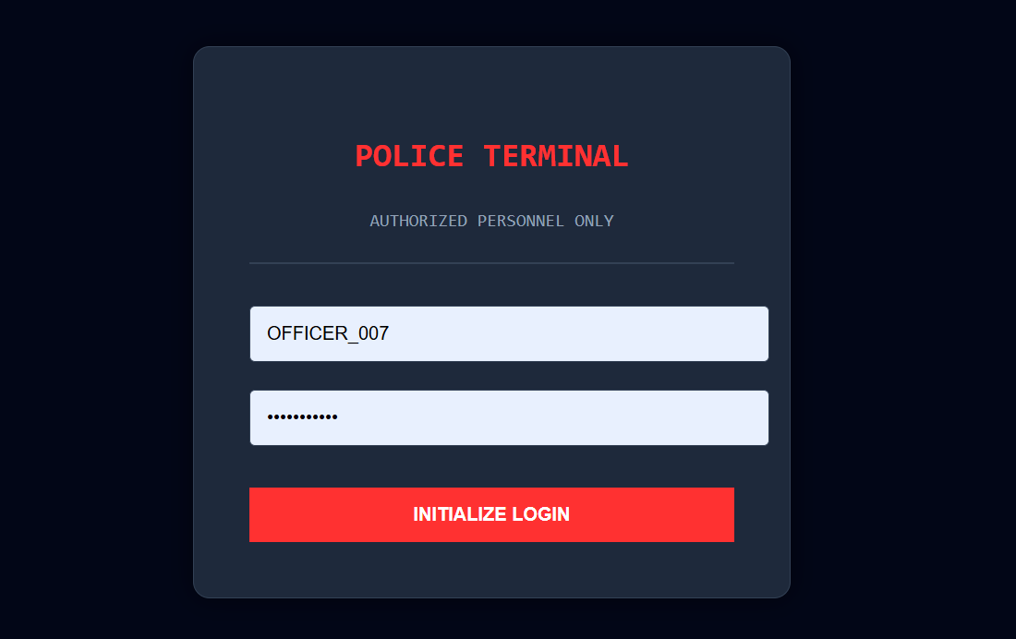
Fig 2: Police Login Terminal Interface

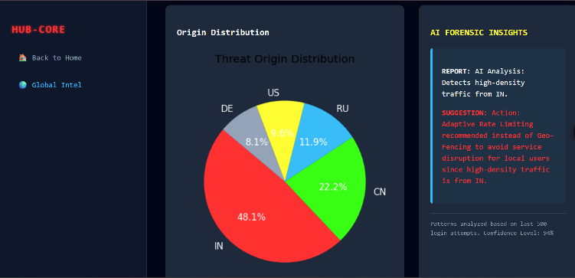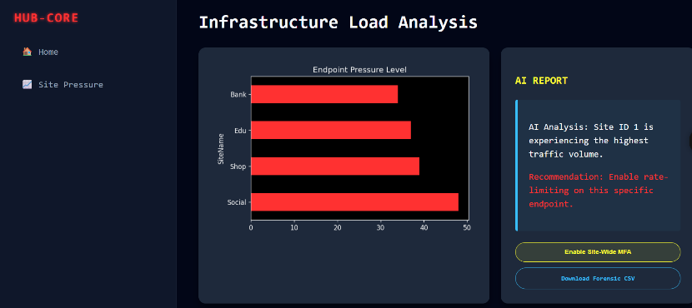

Fig 3: Infrastructure Load Analysis dashboard Fig 4: System Monitoring And Alert Overview

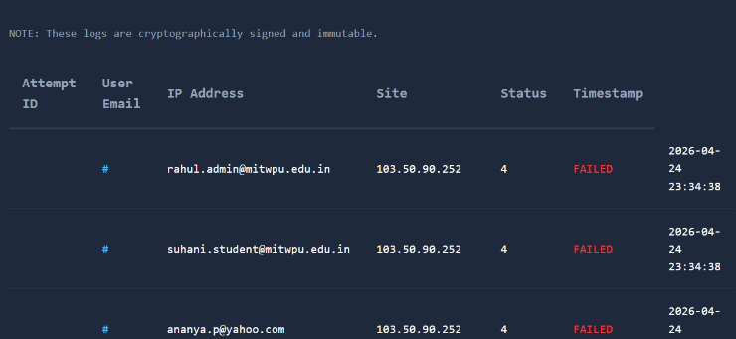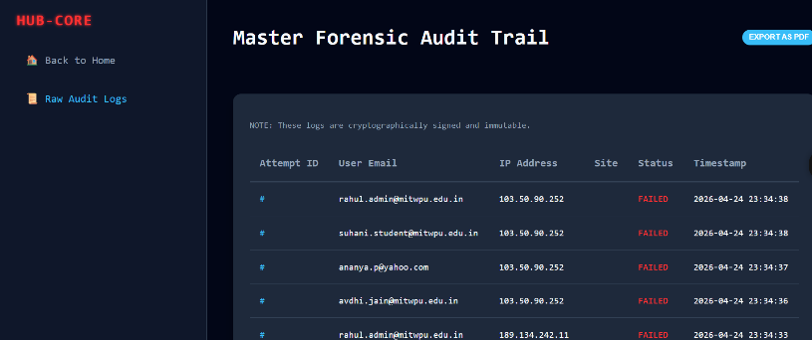

Fig 5: Attempt ID Fig 6: Master Forensic Audit Trail

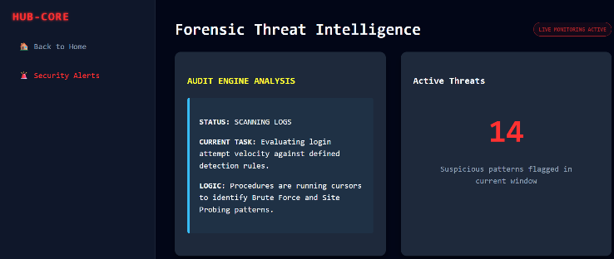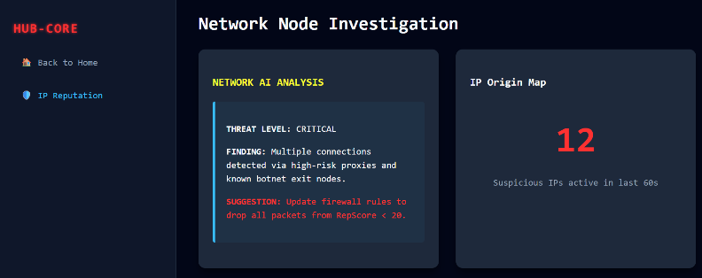

Fig 7: Forensic Threat Intelligence Panel Fig 8: Network Node Investigation Interface

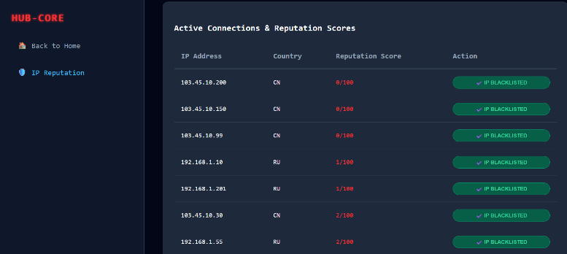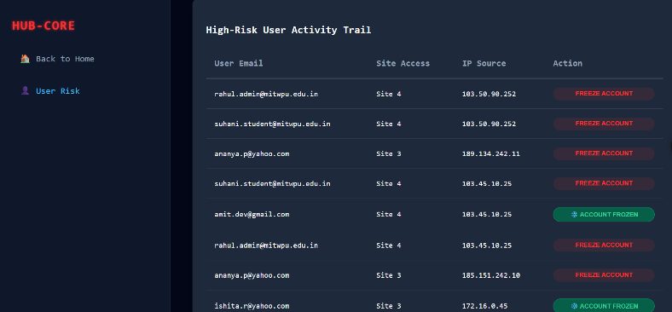
Fig 9: Active Connections And Reputation Score Monitor Fig 10: High-Risk Activity Trail Log

USER LOGIN

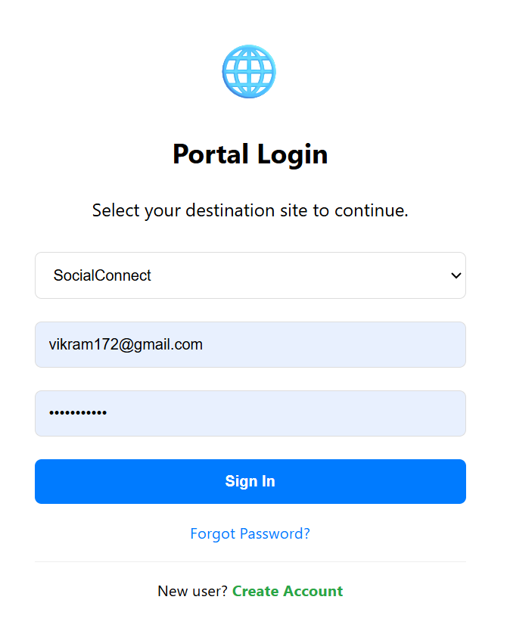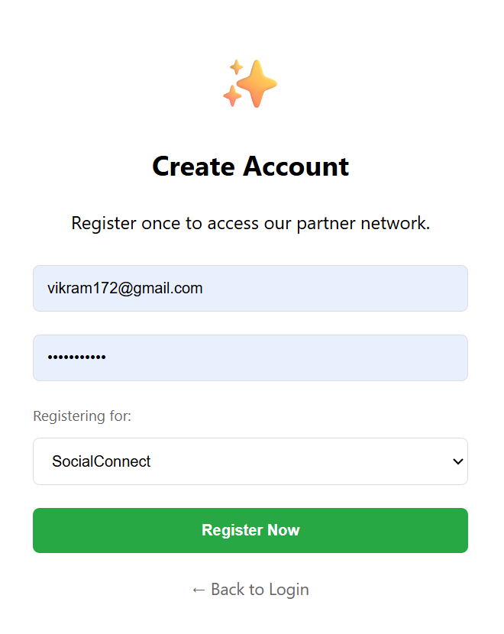

Fig11: User Login Page — Portal Selection and Fig12: Create Account Page — New User Registration Form

Sign In Interface

Conclusion

This project successfully demonstrates how database systems can be integrated with cybersecurity mechanisms to detect suspicious activities. By combining structured data storage, SQL operations, and intelligent analysis, the system improves security and monitoring. It provides real-time alerts and helps administrators take proactive measures. Future improvements can include machine learning models and real-time API integrations.

References

[1] Informatics Practices class 11 by Sumita Arora
[2] Informatics Practices class 12 by Sumita Arora

